TASK 4 — Use Macros Safely

1. Safe Macro Implementations
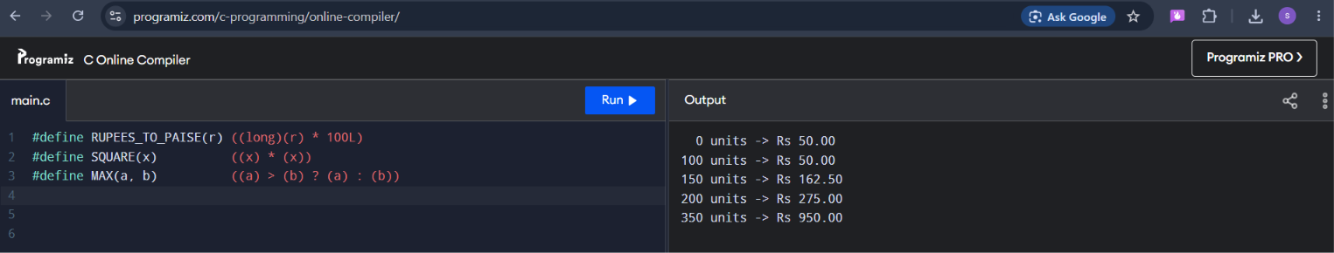
2. Preprocessor Pitfalls Explained
- Grouping Faults: Writing SQUARE(a + 1) as a + 1 * a + 1 evaluates via standard operator order to \(a + a + 1\). Adding explicit inner parentheses ((x) * (x)) guarantees it parses cleanly as ((a + 1) * (a + 1)).
- Double Evaluation: MAX(i++, j) evaluates the post-increment argument twice if \(i > j\), incrementing the index variable tracking state incorrectly.
- Inline Functions: When type safety is critical, a static inline function is preferred over macros. It offers type validation and prevents unexpected side effects while matching macro performance.

